FUNDAMENTALS OF ECONOMICS

UNIT - III

MARKET STRUCTURES

Market is a place where buyer and seller meet, goods and services are offered for the sale and transfer of ownership occurs. A market may be also defined as the demand made by a certain group of potential buyers for a good or service. The former one is a narrow concept and later one is a broader concept. Economists describe a market as a collection of buyers and sellers who transact over a particular product or product class (the housing market, the clothing market, the grain market etc.). For business purpose we define a market as people or organizations with wants (needs) to satisfy, money to spend, and the willingness to spend it. Broadly, market represents the structure and nature of buyers and sellers for a commodity/service and the process by which the price of the commodity or service is established. In this sense, we are referring to the structure of competition and the process of price determination for a commodity or service. The determination of price for a commodity or service depends upon the structure of the market for that commodity or service (i.e., competitive structure of the market). Hence the understanding on the market structure and the nature of competition are a pre-requisite in price determination.

Different Market Structures
Market structure describes the competitive environment in the market for any good or service. A market consists of all firms and individuals who are willing and able to buy or sell a particular product. This includes firms and individuals currently engaged in buying and selling a particular product, as well as potential entrants. The determination of price is affected by the competitive structure of the market. This is because the firm operates in a market and not in isolation. In making decisions concerning economic variables it is affected, as are all institutions in society by its environment.
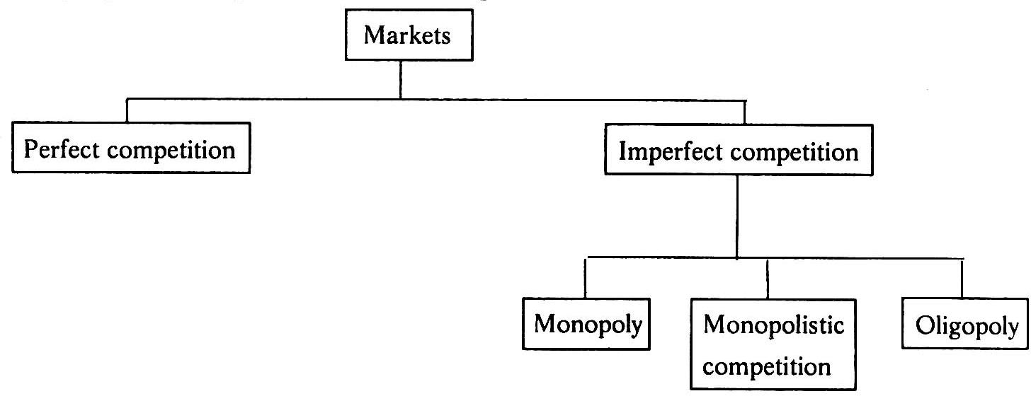

PERFECT COMPETITION

Perfect competition refers to a market structure where competition among the sellers and buyers prevails in its most perfect form. In a perfectly competitive market, a single market price prevails for the commodity, which is determined by the forces of total demand and total supply in the market.

Characteristics Of Perfect Competition
The following features characterize a perfectly competitive market:
    - A large number of buyers and sellers: The number of buyers and sellers is large and the share of each one of them in the market is so small that none has any influence on the market price.
    - Homogeneous product: The product of each seller is totally undifferentiated from those of the others.
    - Free entry and exit: Any buyer and seller is free to enter or leave the market of the commodity.
    - Perfect knowledge: All buyers and sellers have perfect knowledge about the market for the commodity.
    - Indifference: No buyer has a preference to buy from a particular seller and no seller to sell to a particular buyer.
    - Non-existence of transport costs: Perfectly competitive market also assumes the non-existence of transport costs.
    - Perfect mobility of factors of production: Factors of production must be in a position to move freely into or out of industry and from one firm to the other.

Perfect competition: The individual firm
AR(Average revenue) curve and MR(Marginal Revenue) curve under perfect competition becomes equal to D(Demand) curve and it would be a horizontal line or parallel to the X-axis. The curve simply implies that a firm under perfect competition can sell as much quantity as it likes at the given price determined by the industry
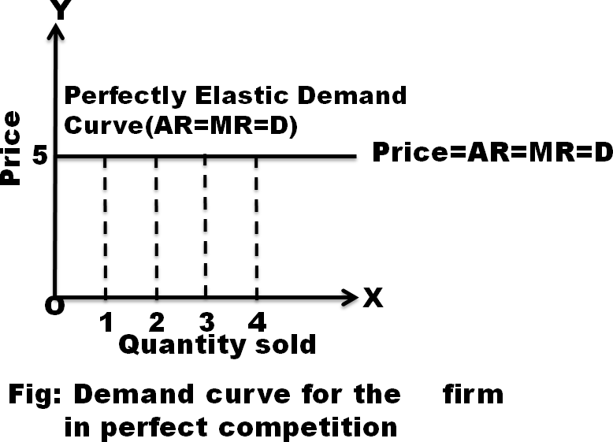
i.e. a perfectly elastic demand curve.

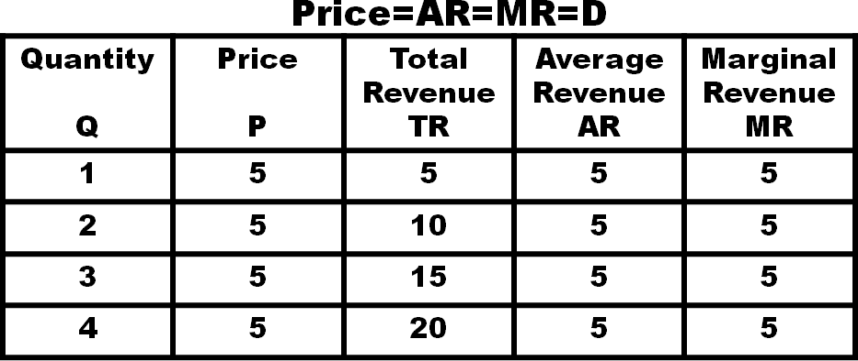

Perfect competition: The firm and the industry
Price is determined by the market forces, that is, demand and supply for a given product or service. As discussed above, firms have no control over the prices they charge for their products. The ultimate price that determines the quantity demanded is equal to the quantity supplied. This price is also called equilibrium price, as it balances the forces of demand and supply. The figure shows how the price is determines. DD is the demand curve and SS is the supply curve. Rs. 6 is the price at which DD and SS intersect each other. At Rs. 6, 60 units are supplied and demanded.
If the price increases to Rs.8, supply will also increase and hence the price is likely to fall down.
If the price decreases to Rs. 4, supply will decrease and hence the price is likely to go up.
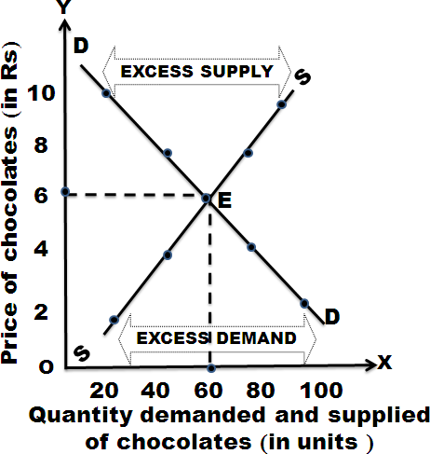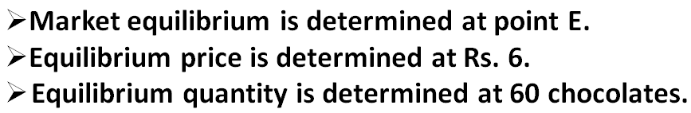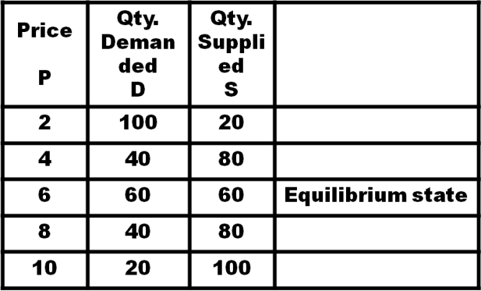
Price-Output Determination Under Perfect Competition
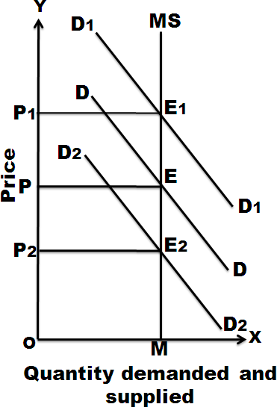
In this market, the price is determined by supply and demand forces. Marshal who propounded the theory says that the price is determined by the equilibrium between demand and supply.
The pricing of commodity under perfect competition can be determined in three periods of time.
- Very short period (Market Period)
Market period is too short period to increase the supply. The market period is so short that supply of the commodity is limited to existing stock. During the market period, say a single day, the supply of a commodity is perfectly inelastic.
In this figure quantity is represented along X-axis and price is represented along Y-axis. MS is the very short period supply curve. DD is
demand curve. It intersects supply curve at E. The price is OP. The quantity is OM. D1 D1 represents increased demand. This curve cuts the supply curve at E1. Even at the new equilibrium, supply is OM only. But price increases to OP1. So, when demand increases, the price will increase but not the supply. If demand decreases new demand curve will be D2 D2. This curve cuts the supply curve at E2. Even at this new equilibrium, the supply is OM only. But price falls to OP2. Hence in very short period, given the supply, it is the change in demand that influences price. The price determined in a very short period is called Market Price.

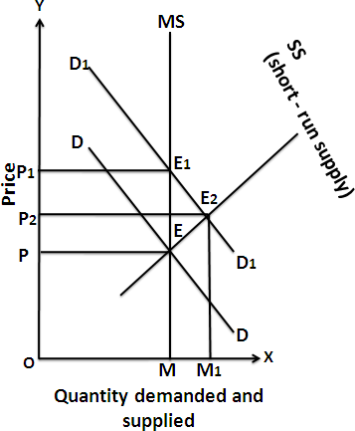
Short Period
Short period is not too long period to install new capital equipments. It is also not sufficient period to permit the new firms to enter the industry to increase the supply of the commodity in the market. Hence the firm can increase the supply of a commodity in the short period only by making intensive use of the given plants and equipments and increasing the units of variable factors.
As a result of this, the short period supply of a commodity will be relatively less elastic.

In the diagram MS is the market period supply curve. DD is the initial demand curve. It intersects MS curve at
- The price is OP and output OM. Suppose demand increases, the demand curve shifts upwards and becomes D1D1. In the very short period, supply remains fixed on OM. The new demand curve D1D1 intersects MS at E1. The price will rise to OP1. This is what happened in the very short-period.
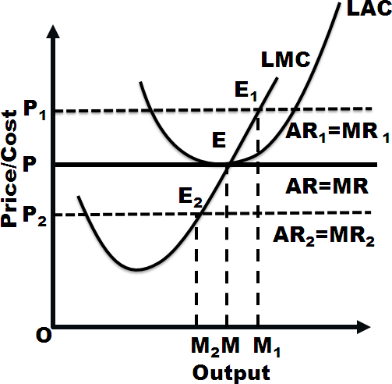
As the price rises from OP to OP1, firms expand output. As firms can vary some factors but not all, the law of variable proportions operates. This results in new short-run supply curve SS. It interests D1 D1 curve at E2. The price will fall from OP1 to OP2.

Long Period
In Long run, the Firm‟s output (supply) can be changed by both the variable factors and fixed factors i.e. all factors become variable. There is enough time for new Firms to enter the Industry. Further, if the demand is increased, the supply can be increased or decreased according to the demand. For Long run equilibrium, long run marginal cost (LMC) is equal to MR and LMC curve cut the MR curve from below. In case of long run equilibrium, all the firms will earn only normal profits.
Take the case when the Firm earn super-normal profit-Then the existing Firm will increase their production and new Firm will enter the Industry. Consequently, the total supply will increase and price fall down and further results in normal profit for the firm
On the contrary, if the firm is incurring losses, Then some Firm will leave the Industry which will reduce the total supply. And due to decrease in supply, price will rise and once again Firm will begin to earn normal profit. Firm equilibrium is at the minimum point of its LAC and at this point the Firm will get the normal profits. If AR (price) rises to OP₁, then Firm‟s LMC cuts its MR1 at E₁ and the firm gets super-normal profit but again come to OP yielding normal profits as stated before. And at price OP_{2,} firm incurs losses but again rise to level OP to maintain the equilibrium at normal profit
Firm‟s equilibrium: MC=MR=AR= min LAC

MONOPOLY
“mono” means single and “poly” means seller. The term monopoly refers to that market in which a single firm controls the whole supply of a particular product which has no close substitutes. Monopoly emerges in firms such as transport, water and electricity supply etc.

Features:
  - Single person or a firm: A single person or a firm controls the total supply of the commodity. There will be no competition for monopoly firm. The monopolist firm is the only firm in the whole industry.
  - No close substitute: The goods sold by the monopolist shall not have close substitutes. Even if price of monopoly product increases, people will not go in far substitute. For example: If the price of electric bulb increases slightly, consumer will not go in for kerosene lamp.
  - Large number of Buyers: Under monopoly, there may be a large number of buyers in the market who compete among themselves.
  - Price Maker: Since the monopolist controls the whole supply of a commodity, he is a price-maker, and then he can alter the price.
  - Supply and Price: The monopolist can fix either the supply or the price. He cannot fix both. If he charges a very high price, he can sell a small amount. If he wants to sell more, he has to charge a low price. He cannot sell as much as he wishes for any price he pleases.
  - Downward Sloping Demand Curve: The demand curve (average revenue curve) of monopolist slopes downward from left to right. It means that he can sell more only by lowering price.

Monopoly refers to a market situation where there is only one seller. He has complete control over the supply of a commodity. He is therefore in a position to fix any price. Under monopoly there is no distinction between a firm and an industry. This is because the entire industry consists of a single firm.
Being the sole producer, the monopolist has complete control over the supply of the commodity. He has also the power to influence the market price. He can raise the price by reducing his output and lower the price by increasing his output. Thus he is a price-maker. He can fix the price to his maximum advantages. But he cannot fix both the supply and the price, simultaneously. He can do one thing at a time. If he fixes the price, his output will be determined by the market demand for his commodity. On the other hand, if he fixes the output to be sold, its market will determine the price for the commodity. Thus his decision to fix either the price or the output is determined by the market demand.
The market demand curve of the monopolist (the average revenue curve) is downward sloping. Its corresponding marginal revenue curve is also downward sloping. But the marginal revenue curve lies below the average revenue curve as shown in the figure. The monopolist faces the down-sloping demand curve because to sell more output, he must reduce the price of his product. The firm‟s demand curve and industry‟s demand curve are one and the same. The average cost and marginal cost curve are U shaped curve. Marginal cost falls and rises steeply when compared to average cost.
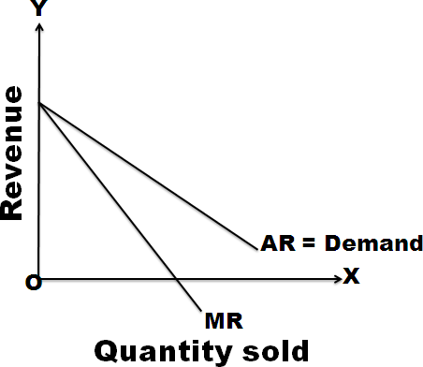
Under monopoly, demand curve is average revenue curve.
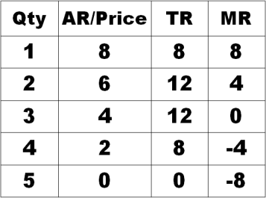

Price-Output Determination Under Monopoly
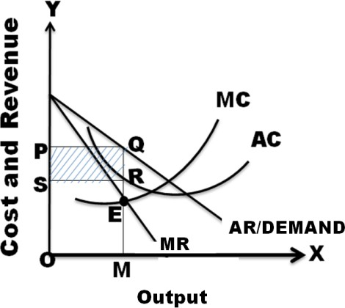
The monopolistic firm attains equilibrium when its marginal cost becomes equal to the marginal revenue. The monopolist always desires to make maximum profits. He makes maximum profits when MC=MR. He does not increasing his output if his revenue exceeds his costs. But when the costs exceed the revenue, the monopolist firm incur loses. Hence the monopolist curtails his production. He produces up to that point where marginal cost is equal to the marginal revenue (MR=MC). Thus, the point is called equilibrium point. The price output determination under monopoly may be explained with the help of a diagram.

In the diagram, the quantity supplied or demanded is shown along X-axis. The cost or revenue is shown along Y-axis. AC and MC are the average cost and marginal cost curves respectively. AR and MR curves slope downwards from left to right. AC and MC are U shaped curves. The monopolistic firm attains equilibrium when its marginal cost is equal to marginal revenue (MC=MR). Under monopoly, the MC curve may cut the MR curve from below or from a side. In the diagram, the above condition is satisfied at point E. At point E, MC=MR. The firm is in equilibrium. The equilibrium output is OM. Up to OM output, MR is greater than MC and beyond OM, MR is less than MC. Therefore, the monopolist is will be in equilibrium at output OM where MR=MC and profits are maximized.
The above diagram (Average revenue) = MQ or OP Average cost = MR
Profit per unit = Average Revenue-Average cost=MQ-MR=QR Total Profit = QR x SR=PQRS
If AR > AC; Abnormal or super normal profits. If AR = AC; Normal Profit
If AR < AC ; Loss

MONOPOLISTIC COMPETITION
Perfect competition and pure monopoly are rare phenomena in the real world. Instead, almost every market seems to exhibit characteristics of both perfect competition and monopoly. Hence, in the real world, it is the state of imperfect competition lying between these two extreme limits that work. Edward. H. Chamberlain developed the theory of monopolistic competition, which presents a more realistic picture of the actual market structure and the nature of competition.

Features/Characteristics
The important characteristics of monopolistic competition are:
- Existence of Many firms: Industry consists of a large number of sellers, each one of whom does not feel dependent upon others. Every firm acts independently without bothering about the reactions of its rivals. The size is so large that an individual firm has only a relatively small part in the total market, so that each firm has very limited control over the price of the product. As the number is relatively large, it is difficult for these firms to determine its price- output policies without considering the possible reactions of the rival forms. A monopolistically competitive firm follows an independent price policy.
- Product Differentiation: product differentiation is the essential feature of monopolistic competition. Products can be differentiated by means of unique facilities, advertising, brand loyalty, packing, pricing, terms of credit, superior maintenance service, convenient location and so on. Through heavy advertisement budgets, Pepsi and Coca-Cola make it very expensive for a third competitor to enter the cola market on such a big scale. The following example illustrate how the firms differentiate themselves from others in a monopolistic environment.
  - In hotel industry, some hotels have spacious swimming pools, gyms, cultural programs etc. The customers who value these facilities don‟t bother about price changes.
  - The colleges who provide best infrastructure and placements in various reputed companies have demand from the student community irrespective of an increase in tuition fee.
  - Cell phones which have unique features have demand from the public even price increases.
- Large Number of Buyers: There are large number of buyers in the market. But the buyers have their own brand preferences. So, the sellers are able to exercise a certain degree of monopoly over them. Each seller has to plan various incentive schemes to retain the customers who patronize his products.
- Free Entry and Exist of Firms: As in the perfect competition, in the monopolistic competition too, there is freedom of entry and exit. That is, there is no barrier as found under monopoly.
- Selling costs: Since the products are close substitutes, much effort is needed to retain the existing consumers and to create new demand. So, each firm has to spend a lot on selling cost, which includes cost on advertising and other sale promotion activities.
- Imperfect Knowledge: Imperfect knowledge about the product leads to monopolistic competition. If the buyers are fully aware of the quality of the product, they cannot be influenced much by advertisement or other sales promotion techniques.
- The Group: Under perfect competition, the term industry refers to all collection of firms producing a homogenous product. But under monopolistic competition, the products of various firms are not identical though they are close substitutes.

Price – Output Determination Under Monopolistic Competition
Under monopolistic competition, Since different firms produce different varieties of products, different prices for them will be determined in the market depending upon the demand and cost conditions. Each firm will set the price and output of its own product. Here also the profit will be maximized when marginal revenue is equal to marginal cost(MR=MC). The demand curve for the firm in case of monopolistic competition is just similar to that of monopoly.
The degree of elasticity of demand of a firm in monopolistic competition depends upon the extent to which the firm can resorts to product differentiation. The greater the ability of the firm to differentiate the product, the less elastic the demand is. The firm‟s influence to increase the price depends upon the extent to which it can differentiate the product.

a) Short-run
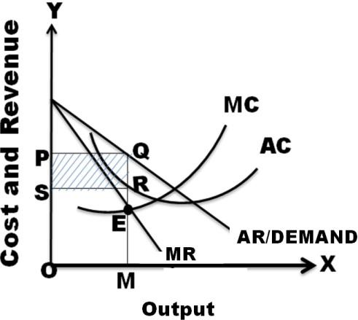
In the short-run, the firm is in equilibrium when marginal Revenue = Marginal Cost. In the figure, AR is the average revenue curve. MR marginal revenue curve, MC marginal cost curve, AC average cost curve, MR and MC interest at point E where output is OM and price MQ (i.e. OP). Thus, the equilibrium output is OM and the price is MQ or OP. When the price (average revenue) is above average cost, a firm will be making supernormal profit. From the figure it can be seen that AR is above AC in the equilibrium point. As AR is above AC, this firm is making abnormal profits in the short-run. The abnormal profit per unit is QR, i.e., the
difference between AR and AC at equilibrium point and the total supernormal profit is OR x OM. This total abnormal profits is represented by the rectangle PQRS. The firm may make supernormal profits in the short-run if it satisfies the following two conditions.
- MR = MC
- AR > AC
b) Long–run

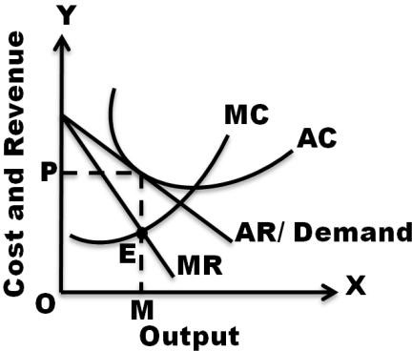
More and more firms will be entering the market having been attracted by supernormal profits enjoyed by the existing firms in the industry. As a result, competition become s intensive on one hand, forms will compete with one another for acquiring scare inputs pushing up the prices of factor inputs. On the other hand, on the entry of several firms, the supply in the market will increase, pulling down the selling price of the products. In order to cope with the competition, the firms will have to increase the budget on advertising. The
entry of new firms continue till the supernormal profits of the firms completely eroded and ultimately firms in the industry will earn only normal profits. Those firms which are not able to earn at least normal profits will get closed. Thus in the long-run, every firm in the monopolistic competitive industry will earn only normal profits, which are just sufficient to stay in the business. It is be noted that normal profits are part of average costs.
In the long-run, in order to achieve equilibrium position, the firm has to fulfill the following conditions:
- MR = MC
- AR = AC at the level of equilibrium level of output.

OLIGOPOLY
The term oligopoly is derived from two Greek words, oligos meaning a few, and pollen meaning to sell. Oligopoly is the form of imperfect competition where there are a few sellers in the market, producing either a homogeneous product or producing products, which are close but not perfect substitute of each other.

Features
- Monopoly Power:
There is a clement of monopoly power in oligopoly. Since there are only a few firms and each firm has a large share of the market. In its share of the market, it controls the price and output. Thus an oligopoly has some monopoly power.

Interdependence of Firms:
Under oligopoly, there are only a few firms, each producing a homogeneous or slightly differentiated product. Since the number of firms is small, each firm enjoys a large share of the market and has a significant influence on the price and output decisions. Thus, there is interdependence of firms. No firm can ignore the actions and reactions of rival firms under oligopoly.

Conflicting Attitude of Firms:
Under oligopoly, two types of conflicting attitudes are found in the firms. On the one hand, firms realize the disadvantages of mutual competition and desire to combine to maximize their joint profits. This tendency leads to the formation of collusion. On the other hand, the desire to maximize one‟s individual profit may lead to conflict and antagonism; the firms come into clash with one another on the question of distribution of profits and allocation of markets. Thus, there is an existence of two opposing attitudes among the firms.

Few firms. In this market, only few sellers are found:
For example, the market for automobiles in India exhibits oligopolistic structure as there are only few producers of automobiles. If there are only two firms, it is called „duopoly‟.

Nature of product:
If the firms product homogeneous product, it becomes pure oligopoly. The firms with product differentiation constitute impure oligopoly.

Interdependence among firms:
In oligopoly market, each firm treats the other as its rival firm. It is for this reason that each firm while determining price of its product, takes into account the reaction of the other firms to its own action.

Large number of consumers:
In this market, there are large numbers of consumers to demand the product.

